Unity Comments translator.

Contents

1. Disclaimer: 2

2. General purpose: 2

3. Trouble shooting: 2

4. Unity Comments extraction: 3

4.1. Extracted file format (pivot format) 3

4.2. Command Line tool: 4

Restriction / usage 5

Log 6

Examples: 6

4.3. Excel add ins: 7

# Disclaimer:

**These tools are provided as is and may not have been tested exhaustively.**

**The use of these tools does not imply any responsibility for Schneider Electric.**

# 2. License:

This tool and the associated source is delivered under MIT license. Please read the associated license file.

# General purpose:

These tools are intended to provide help to fasten action in unity and or do bulk operations.

They are provided primarily as command line tools. For the sake of example, it can also provide an Excel add Ins or any other GUI. Excel extensions are provided as a zipped setup.

NB: Excel add Ins require at least excel 2010 installed

# Trouble shooting:

In some cases the “add in” may not load on excel 2010. This is usually due to a wrong version of the [Microsoft VSTO 2010 Runtime] (vstor_redist.exe) – Minimum required version: 10.0.60724

The folder Pre-Requisite contains the redistribution for:

* .net 4.61
* Microsoft VSTO 2010 runtime

# Unity Comments extraction:

This tool allows to extract and re-inject translated/modified comments into unity applications. The comments can be translated outside. It allows bulk operations.



## Extracted file format (pivot format)

The extracted informations are stored in xml format. The xml schema and example:

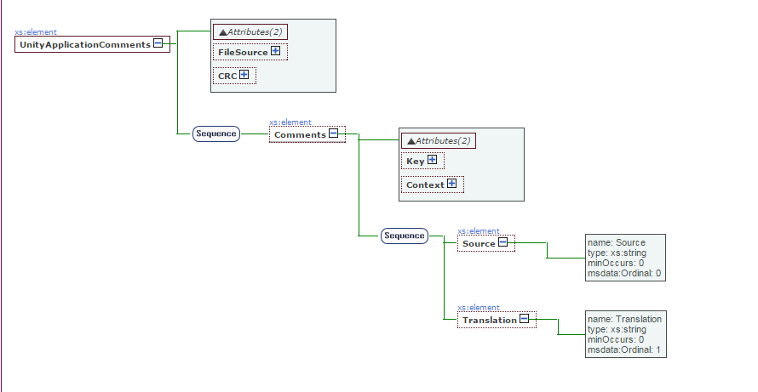

Example:

(Arabic translation)

## Command Line tool:

UnityTranslator.exe {command} {parameter1} {parameter2}

|  |  |  |  |
| --- | --- | --- | --- |
| Command | Parameters1: | Parameter 2: | Comments |
| Extract | IN: Path of the Unity application file to read comments from. Could be STU/STA/ZEF. | OUT : xml file to store the resulting model (comments) | Pre-condition: {parameter1} is a valid unity application file.  Reads all comments from application {parameter1} and save it into (parameter2).   * Post-Condition: the file contains all comments from the unity applications. |
| Translate | IN-OUT :Path of the xml file which contains the comments to translate | IN : Language to translate to | Pre-condition: {parameter 1} is a valid comment xml model. {parameter2} is the code of a supported language.  The tool will automatically translates the comments into the given language using Microsoft translate service. NB: a key for Microsoft translate is included but is limited to 2 000 000 char per month.   1. The resulting xml contains all comments and their translation in the given language {parameter2}.   Remark: the original xml (parameter1) file is saved as .back before being translated. |
| Apply | IN :Path of the xml file containing the comments and their translations | OUT: Path of the Unity application file to update comments (.ZEF). | Pre-condition: {parameter1} is a valid file.  Updates application provided in {Paramater2} with the translations in the model {Parameter1}.   1. The resulting applications are conform to the model. |

## Restriction / usage

Remark: since 1/4/17 this paragraph is obsolete. Microsoft has moved the service, and some changes are needed to access the Microsoft Azure services instead of AzurMarket.

The existing code is based on old version of the Microsoft translator. It is up to the user to adapt it to the new platform, but the principle stay valid.

The extract and apply commands does not require any connection with Microsoft Translator. The Translate command do. In order to use this automatic translation, you need to have access to Microsoft Translator©. By default, the tool is delivered with 2 limited (free) sample account access.

The keys used to require automatic translations (translate command) are stored in SE.UnityTranslator.exe.configfile for the command line tool and SE.UnityTranslatorExcel.dll.configfile for the excel plugin.

The tool supports up to 4 keys.

To replace the keys with your own account:

1) Create a keys in Microsoft translate tool as defined here: (steps1-4)

https://msdn.microsoft.com/en-us/library/mt146806.aspx

2) Update the .config file with MicrosoftTranslatorAccountkey as your client ID and MicrosoftTranslatorAccountPwd as your client secret.

NB: the keys are ordered. The tool will try the first, if it fails the second …. So put your own at first.

**UnityComments.dll.config. extracted part:**

*<userSettings>*

*<SchneiderElectric.UnityComments.Properties.Settings>*

*<setting name="MicrosoftTranslatorAccountkey1" serializeAs="String">*

*<value>se-unitytranslator</value>*

*</setting>*

*<setting name="MicrosoftTranslatorAccountPwd1" serializeAs="String">*

*<value>FRWWzrS22b5x0nrhnI2vljYenTbv+LhxMF4SAdKQaF4=</value>*

*</setting>*

*<setting name="MicrosoftTranslatorAccountkey2" serializeAs="String">*

*<value>unitytranslator-se</value>*

*</setting>*

*<setting name="MicrosoftTranslatorAccountPwd2" serializeAs="String">*

*<value>L3McgaNVzU+RhmPN2pK5JlJjaaRGHyBqmPT3Z4REN0M=</value>*

*</setting>*

*<setting name="MicrosoftTranslatorAccountkey3" serializeAs="String">*

*<value />*

*</setting>*

*<setting name="MicrosoftTranslatorAccountPwd3" serializeAs="String">*

*<value />*

*</setting>*

*<setting name="MicrosoftTranslatorAccountkey4" serializeAs="String">*

*<value />*

*</setting>*

*<setting name="MicrosoftTranslatorAccountPwd4" serializeAs="String">*

*<value />*

*</setting>*

*</SchneiderElectric.UnityComments.Properties.Settings>*

*</userSettings>*

## Log

A log file is created and contain all actions/ errors.

It is located in: %programdata%\Schneider Electric\Translator

## Examples:

Extract:

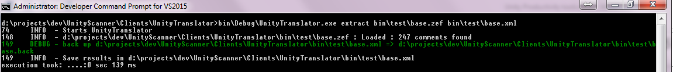

Apply:

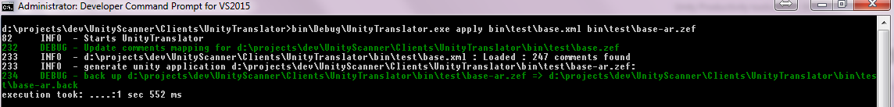

Translate:

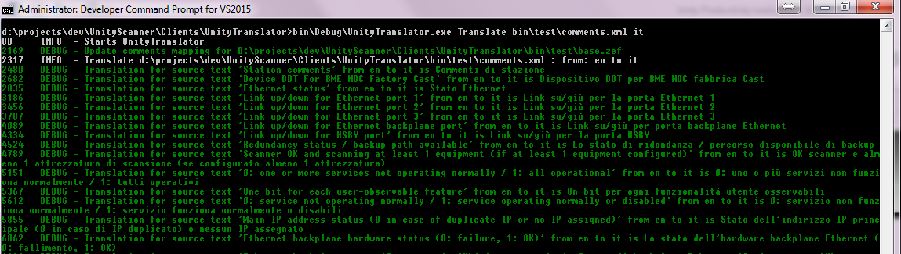

## Excel add ins:

The Excel add in is designed to help doing bulk modifications/translations to all comments in a unity application. It allows to display, and modify the displayed comments using the power of excel. As it is based on the same xml model (cf 5.1), it may be useful to mix batch operations using command lines and edition operation using excel sheet.

After installation of the unity comment excel plugin, open Excel.

In the add-ins tab, you will find a bar with green buttons:

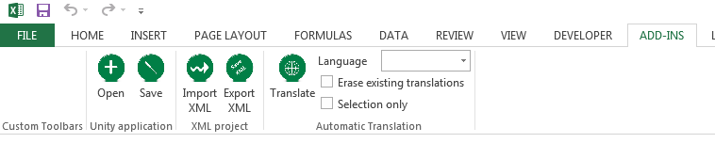

The buttons allow to pilot the extraction translation and generation of the comments.

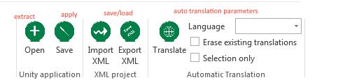

Usually the flow is:

* open unity project.

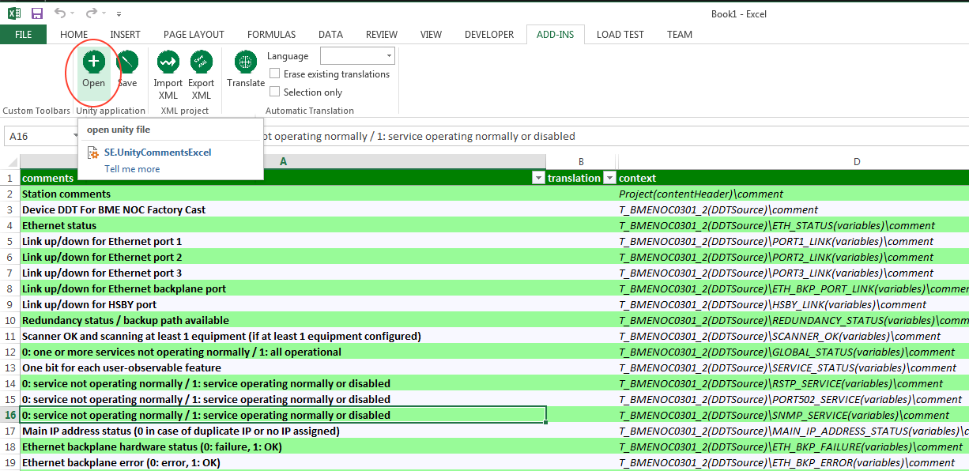

This will open the project, read the content, extract the comments and display them.

In this result sheet, the model structure is flat. Each line represent one comment in the source application. The second column will contain the translations/modifications of the comment at this stage it is empty (just read an application), and then in column D the context is displayed. The context helps the operator to understand from where comes the comment: is it a comment in a code section or in the station properties or on a variable etc….

* Modify / translate the comments for example copy column A in column B and modify some of them. NB: during the save operation, if a comment is not translated/modified (empty col B) the original comment is used.
* Use the automatic translation: the tool allow to use Microsoft translator to propose a first version of the translation for the comments. For sure it needs to be checked but could be a quick first loop.

When using the automatic translation, you need to:

* Select the target language (source language will be determined automatically)
* Adapt the combinable options as desired:
  + Check “erase existing translation” if and only if you want to re translate all comments, even the one already done (non-empty col B). If this option is unselected, only the non Blanc items will be translated.
  + Check “selection only” if you want to submit only the selected items to the translator. If not selected, the whole file is submitted.

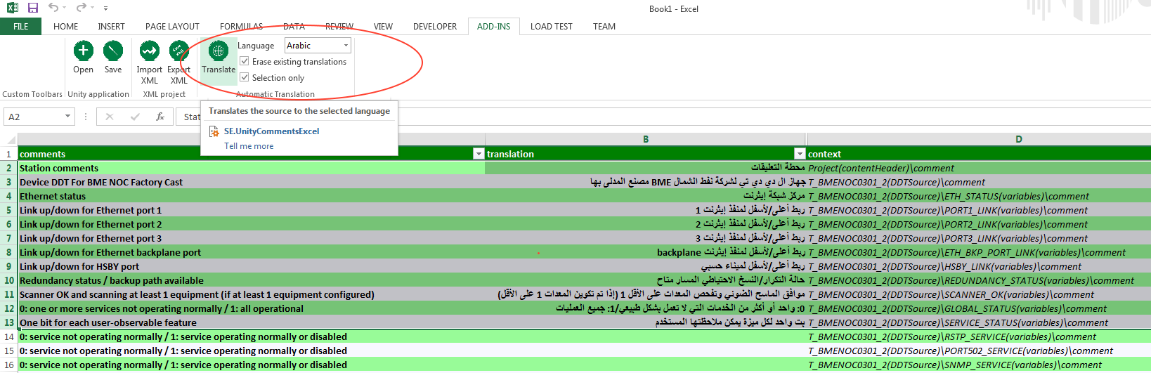

* Save the model, to be able to reopen it more quickly later.

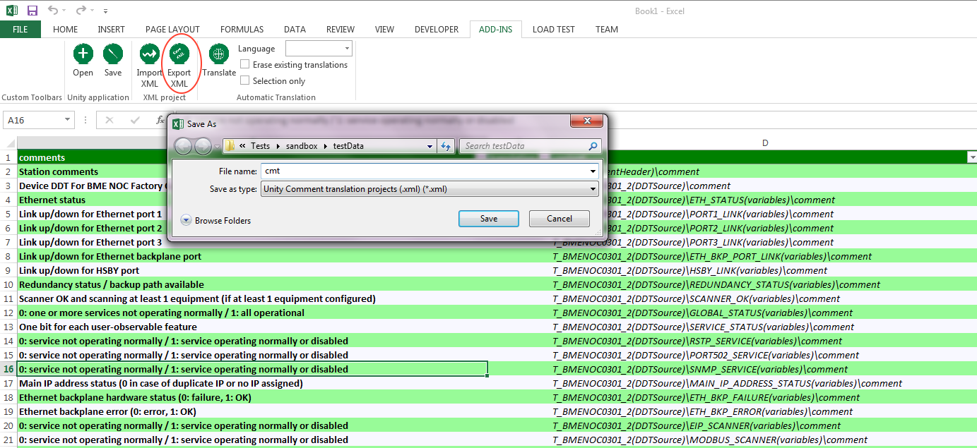

* Update unity applications

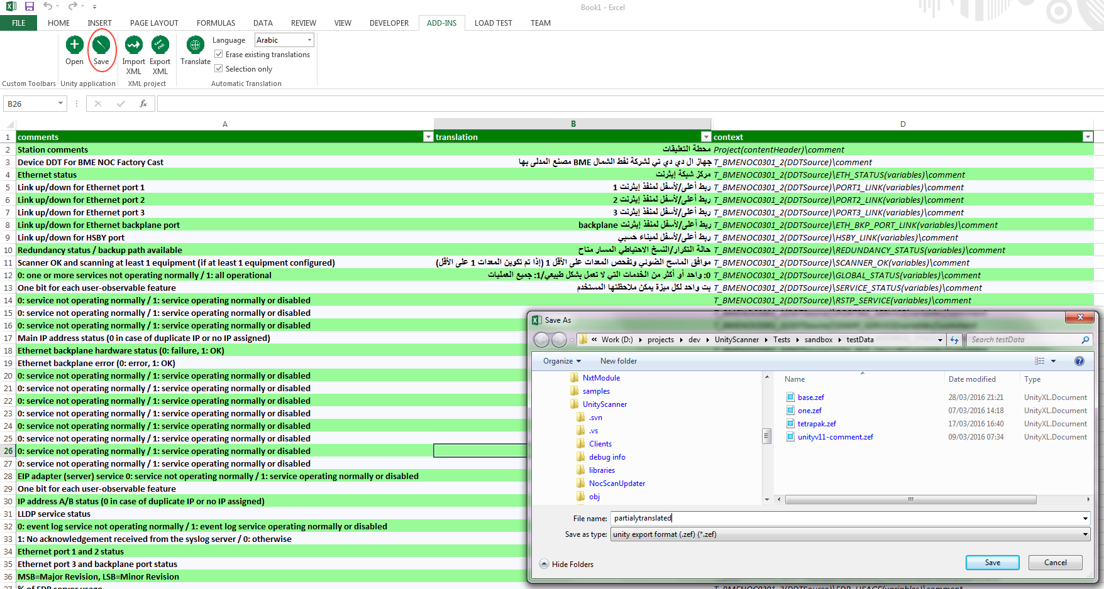

This will update the application with the translations/modifications.

* Load model

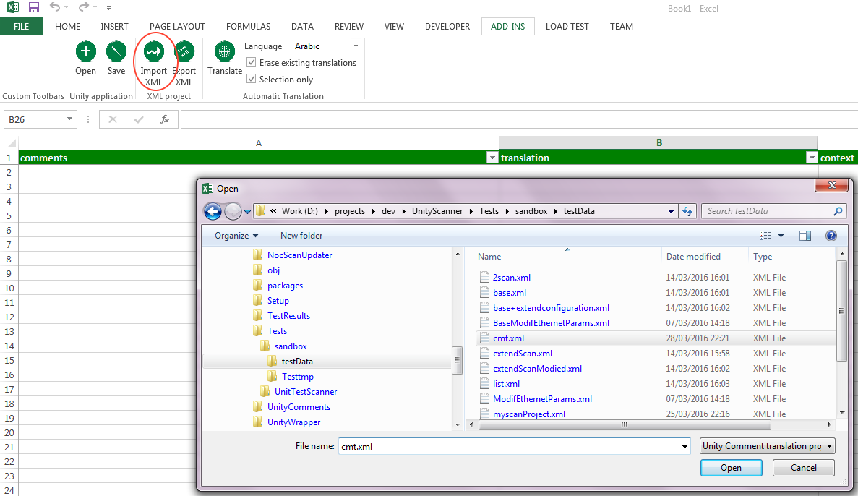

This will reload the xml file into the worksheet